# Heat transfer and turbulent flow of alloy a383 in a HPDC feeding gate

Assumptions:

- No natural convection

- Material properties calculated using pseudo-binary method (Nova database)

- Constant inlet flow velocity (0.5 m/s) boundary condition, inlet fluid temperature 630 C

- Static pressure outlet boundary condition

- Constant temperature condition on walls. Wall temperature 300 C, steel mould material H13 (data from Nova).

- Standard k-epsilon model with enhanced wall function

-steady state

- No solidification

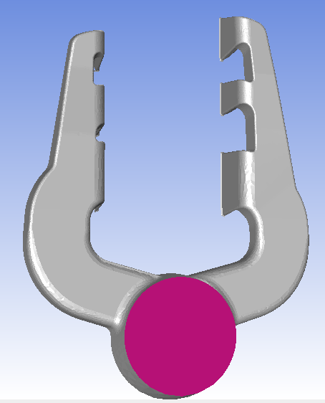

Fig. 1 Velocity inlet

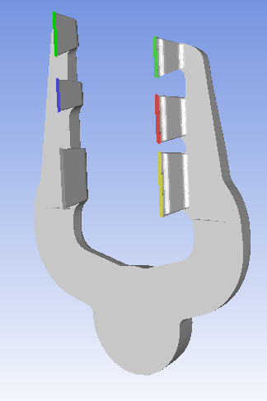

Fig. 2 Pressure outlets

Table 1. Data for A383

A383 data

|  |  |  |  |  |  |  |  |  |
| --- | --- | --- | --- | --- | --- | --- | --- | --- |
| Density (kg/m3) | Cp (J/kgK) | Thermal conductivity (w/mK) | Viscosity (kg/ms) | T_L:  ( C ) | T_S:  ( C ) | Turbulent intensity | Turbulent viscosity ratio | Inlet velocity m/s |
| 2485 | 964.3 | 96 | 0.0017894 | 593 | 539 | 5 % | 10 | 0.5 |

H13 Data

|  |  |  |  |
| --- | --- | --- | --- |
| Density (kg/m3) | Cp (J/kgK) | Thermal conductivity (w/mK) | Temperature (constant) |
| 7600 | 590 | 29 | 300 K |

# Results

Simulation didn’t converge after 1900 iterations. Most residuals went down 3 magnitudes. However, energy didn’t go down 6 magnitudes, which Fluent requires for convergence.

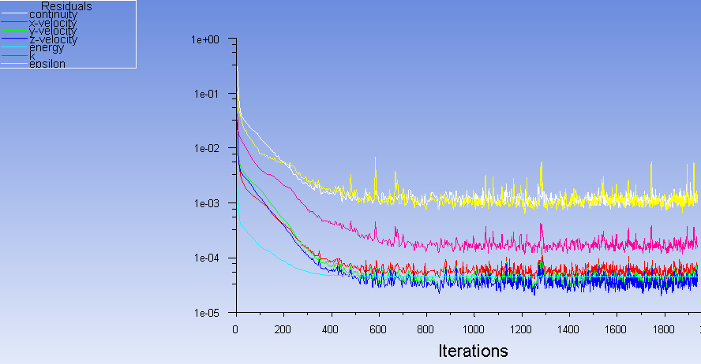

Fig. 3 residuals

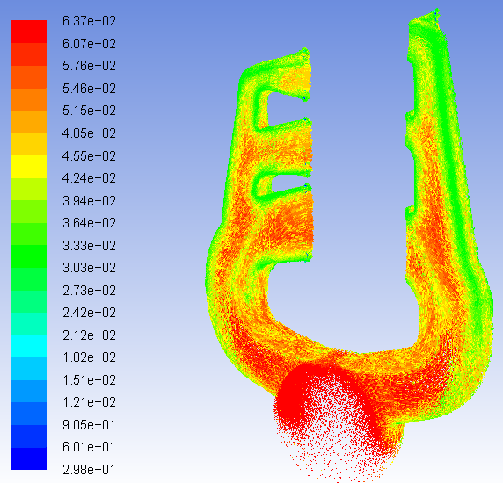

Fig. 4. Flow pattern and temperature of liquid. Note: temperatures under solidus in many areas, which is not realistically accounted for due to no solidification in model.

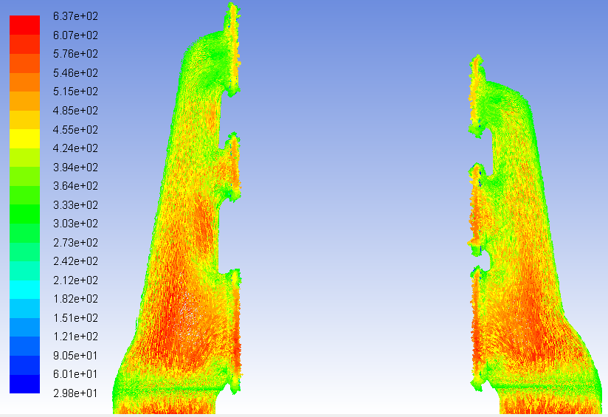  
Fig. 5 Temperature of gates. Only some areas in the bottom gate are above liquidus temperature 593 C. Other gates would be frozen.

# Conclusions

The liquidus and solidus temperatures are 593 and 539 C respectively. We can see that the top two gates fall under the solidus temperature. This suggests that the top two gates might freeze before filling is finished. Next steps are to simulate the mould temperature boundary condition more realistically. The cooling effect of the mould is overestimated in this model, since heating of the mould is not simulated. After this inaccuracy is addressed, we will create an UDF for the inlet boundary condition based on actual HPDC process. Then a transient model can be implemented. Eventually, the effect of solidification can be taken into account.